**FPT APTECH – COMPUTER EDUCATION**



***Topic:* eProject Specification - HTML5 - DURABLE_FURNITURES**

**Teacher: MR. QUẢNG**

**Members: Group 4 – Class: T2103E**

1. **Trần Bá Vinh (Leader)**
2. **Đỗ Đức Thắng**
3. **Trần Ngọc Thiện**
4. **Vũ Hồng Quân**
5. **Lê Thị Phương Hồng**

**Hanoi - Vietnam 07/2021**

eProject Report

1. Acknowledgements (lời cảm ơn)

2. eProject Synopsis (tóm tắt)

3. eProject Analysis (phân tích dự án)

4. eProject Design

a. DFD’s

b. FlowCharts

c. Process Diagrams

d. Database Design / Structure

5. Screen Shot’s

6. Source Code with Comments

7. User Guide

8. Developer’s Guide

9. Module Descriptions

**1. Acknowledgement.**

First of all, our team would like to send a special thanks to Mr. Nguyen Van Quang and the teachers of FPT-Aptech for giving us the opportunity to carry out a project on durable furniture. This project gave our team the opportunity to learn and better understand the furniture field and how to arrange it properly and beautifully. Mainly we have learned significant knowledge on coding, teamwork in real practical project. We already achieved much progress on Responsive tasks for different sizes of devices from very small to popular screen. The detail instruction of project description helped us to know, imagine and understand more on the steps that we would work later on working-environment of our jobs. We knew how to handle the orders from the site owners and also we learned the ways of thinking of site’s customers. We could complete fully a full website with different pages with a compact package project code files and suitable structure. We would kindly appreciate for all of the helps and supports.

The second thank you I would like to send to my teammates, the team members who have been with me on this wonderful project for the past 1 month, once again thank you very much.

**2. Eproject synopis.**

Nowadays, buying, selling and paying online on online platforms has become popular. Goods such as daily household items, beauty products, school supplies, etc. are being sold very popularly on online sales platforms. But for the furniture, we find that the number of peope choosing a product such as a table or chair on the online platform is quite small, people give priority to going to the store and seeing these products first-hand before choosing and buying.

Understanding this problem, our team has created a website full of product information in a very thorough manner in the hope of giving customers the most accurate view of the product being sold. on the website as the material of each product part to the layout and color scheme with each customer's house and room.

**3.4.5 Eproject Analysis, Eproject Design and Screenshot**

As for the website, we divide it into 3 parts like other popular websites: navigation bar, body and footer

Website is developed using HTML, CSS, Javascript is the foundation of most websites, basic e-commerce functionality in the website can be achieved through Javascript.

The homepage of a website is the first page a user notices when entering the website's url in the browser address area. The entire website depends on how the homepage is designed, which forms the basis for viewing other web forms. In short, a home page makes up the summary of the entire website.

Links and Websites: Through the homepage, several other websites may be linked. Each link provides a specific detail about itself with full listings and photos.

The homepage contains a brief description of the entire site.

**Home page includes:**

- The navigation bar navigates to the sections located on the website.

- Image of banner slider at the top of the page

- The type of furniture products includes: Dining room furniture, bedroom furniture and living room furniture. Each category will be products such as tables and chairs suitable for that type of furniture.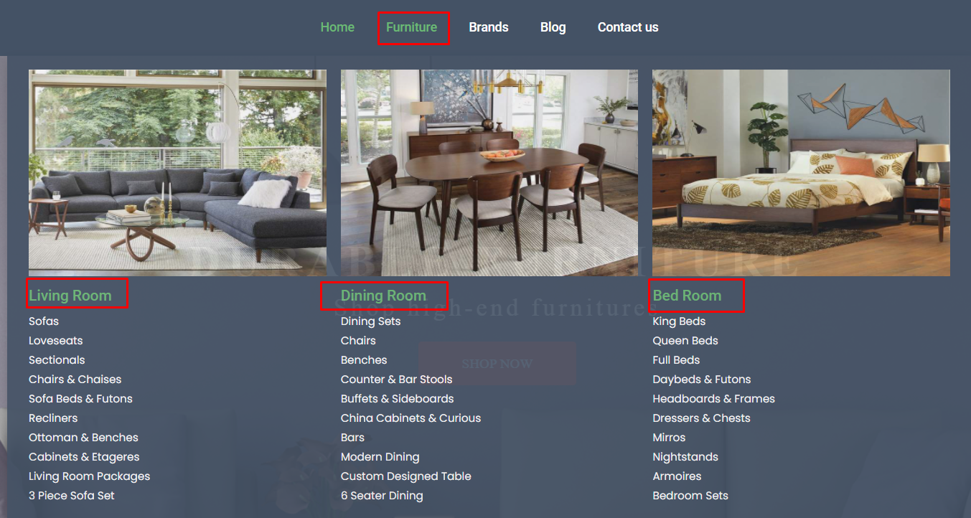

- Well-known brands section: Here we will point out some brands that we think have a high reputation in the market for product quality and price. And Of course, clicking on each brand will display the products of that brand.



- Banner CallToAction: Encourage customers to view products on durable furniture available.

- Product suggestions: List of products on sale, old products on sale and a collection of new products on sale on the website

- Popular products: Products that are bought a lot on the web store

- Pictures of some room layouts with our products

- Banner CallToAction: Encourage customers to view products on durable furniture available.

- New products are on sale on the booth

- Banner and button when clicked will show a short story about our company

- Latest articles on the web

- Footer will include information: about us, customer care, terms of sale, where to send an email if you have any problem contact us and the social networking sites we are working on, active, stay tuned!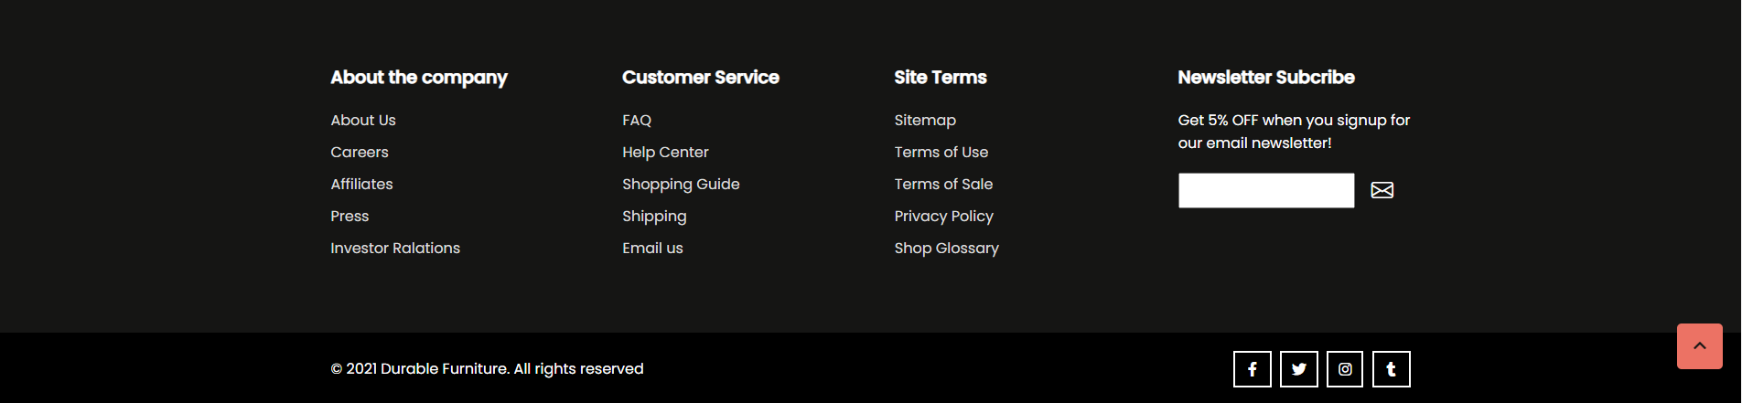

-Movetotop: Back to top of site.

**Furniture: In the navigation bar**

When hovering over the Furniture section, the screen will display a menu consisting of the main rooms, Living Room, Dining Room and Bed Room. And small menus with product names in them.

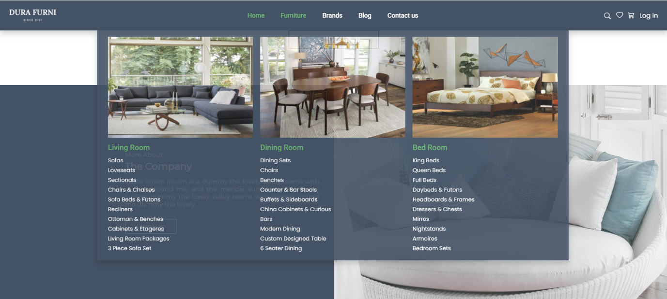

And when we click on it, we will be taken to the Product List page

**Product List:**

The Product List shows us a banner displaying the Brand name on the left side of the menu bar and the right side is a list of products.

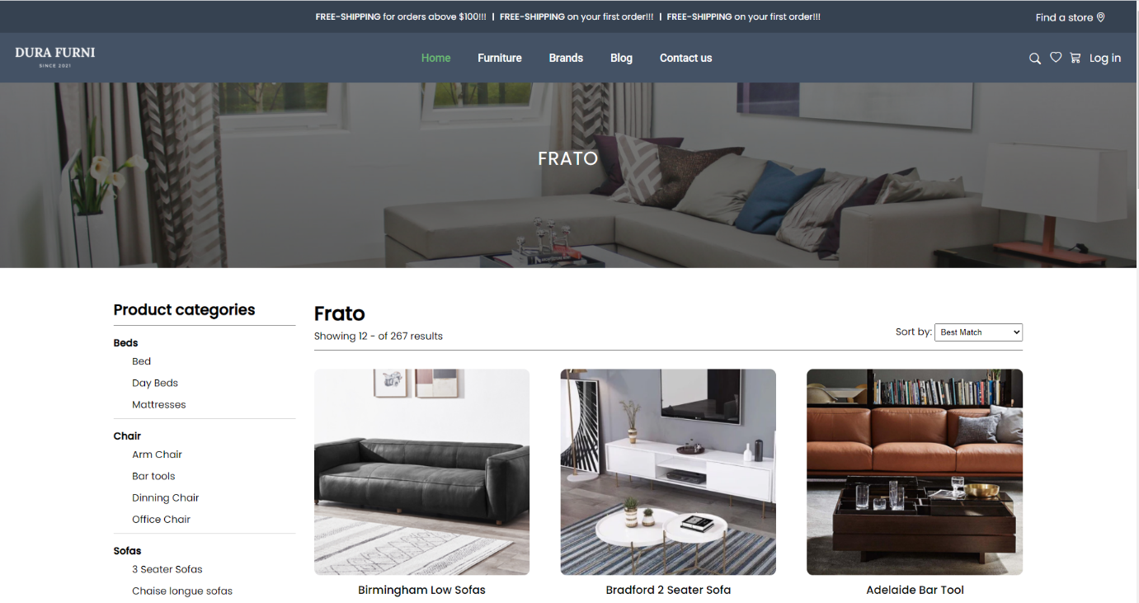

In the menu section contains the items: Product Categories, Color, Search By Price, Best Seller.

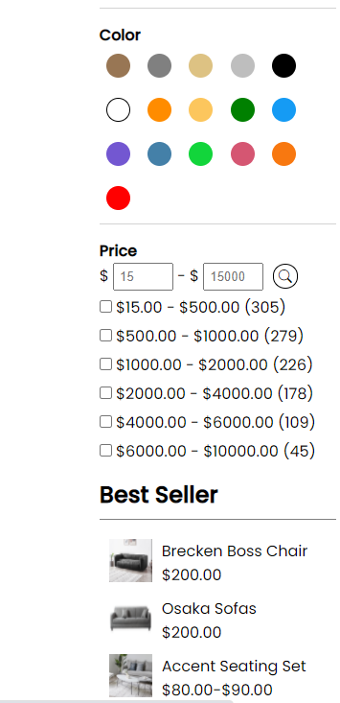

In the Product List we can see photos of the products. sort by search bar and 4 main buttons that link to Details, Add to Cart, Compare and Wishlist pages.

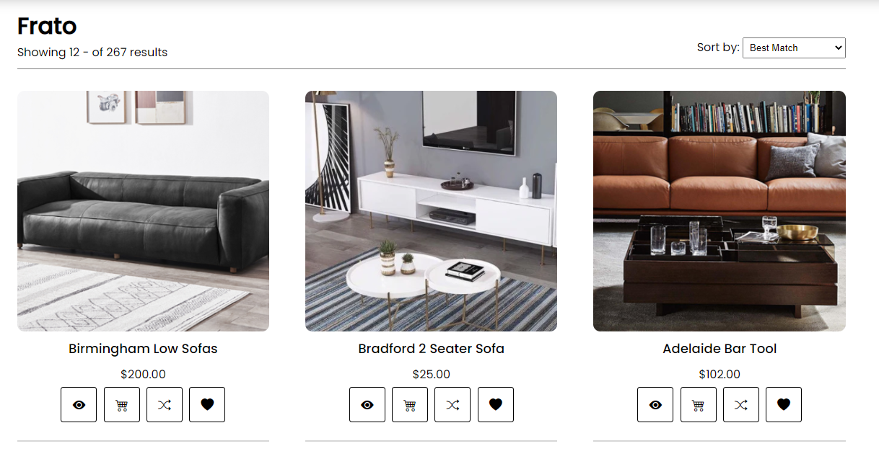

**Details page**

When we click on the detail button (eye icon) we are taken to the detail product page with product details, price, details, purchase quantity and add to cart button.

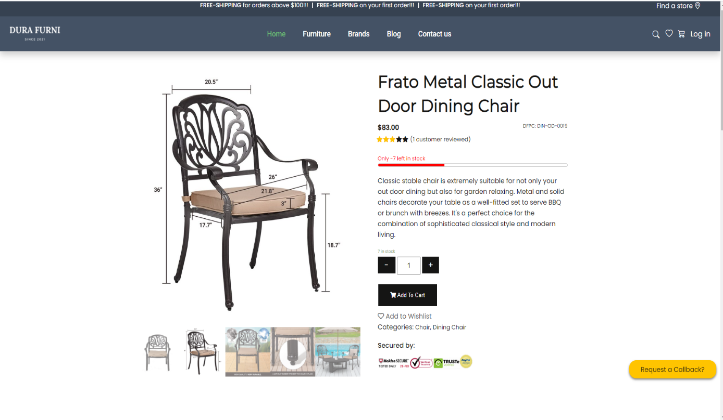

Also in the detail product section we can see Description, product review and Download Description to see more product details.

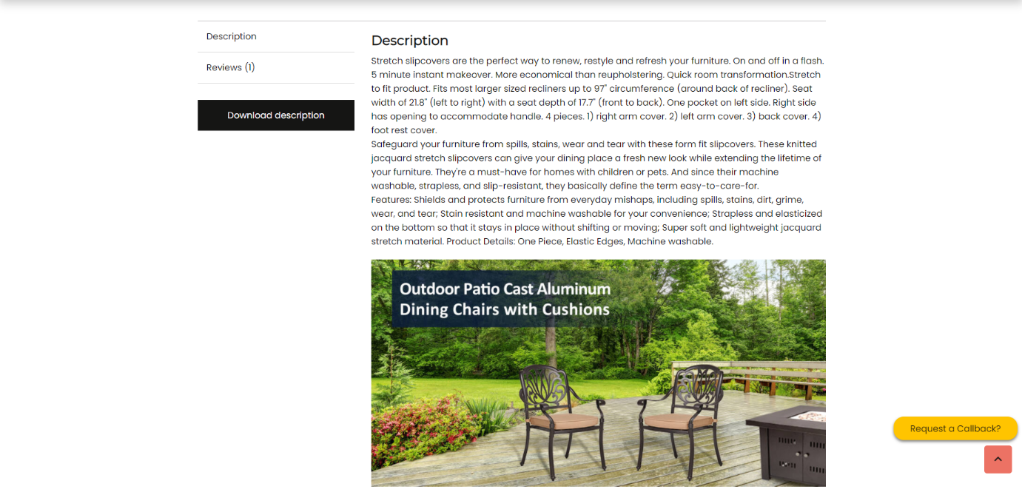

**Cart**

After clicking on the cart (Shop icon) we are taken to the Cart page where the product we have selected is displayed and we can edit the quantity we buy and apply the discount coupon.

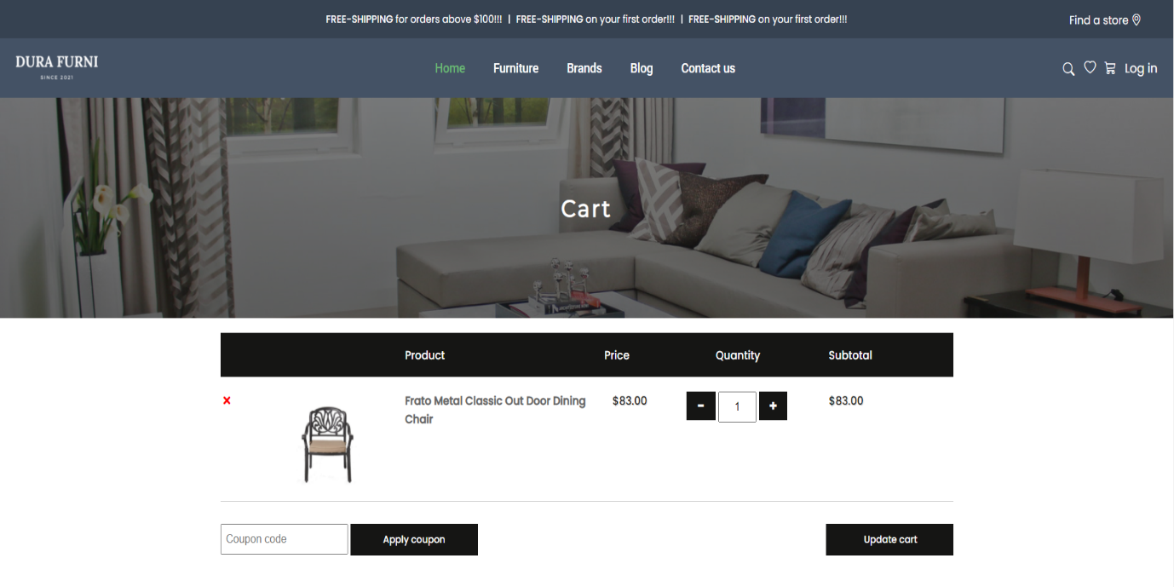

Besides, the Cart also suggests us more good products that can be purchased and the price list including SHIP FEE.

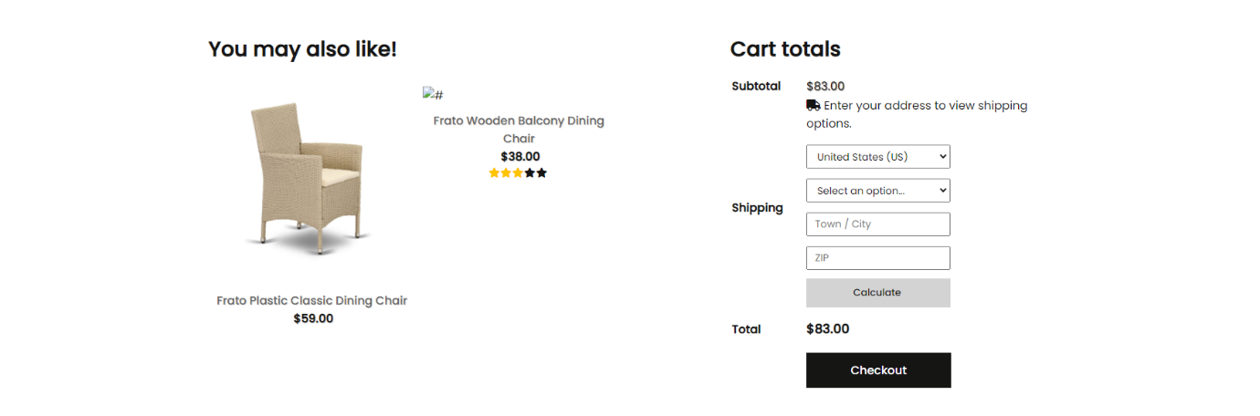

**Product Comparison**

On this page we can choose 2 comparable products to display detailed product information

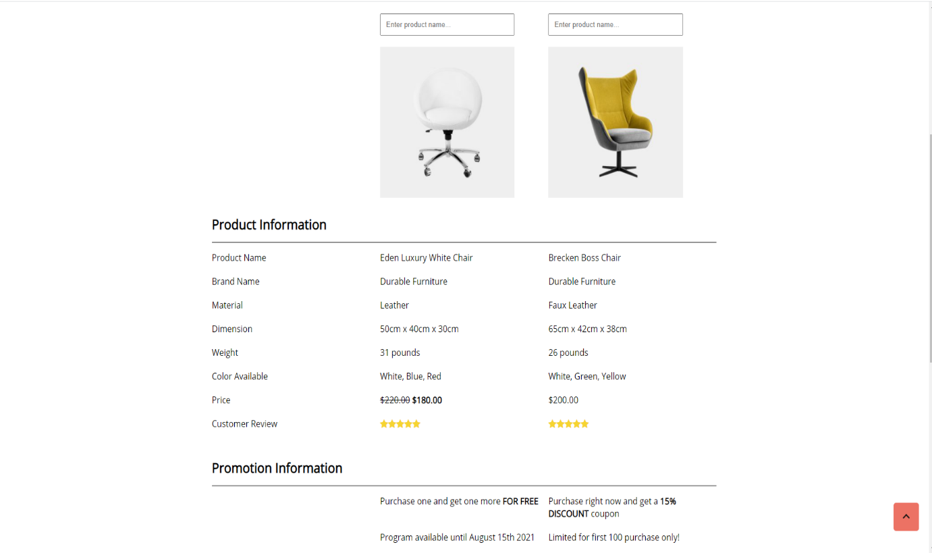

**Blog: In the navigation bar**

* Blog, when clicked, will display articles about experiences and sharing about how to arrange furniture in the room.

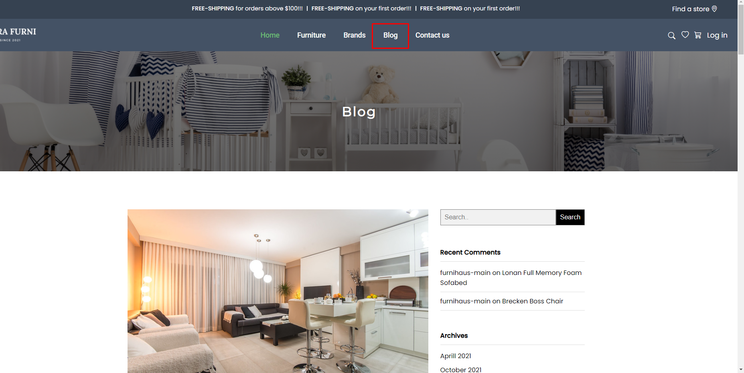

If you want to see more carefully, you can click on Read More and read the article:

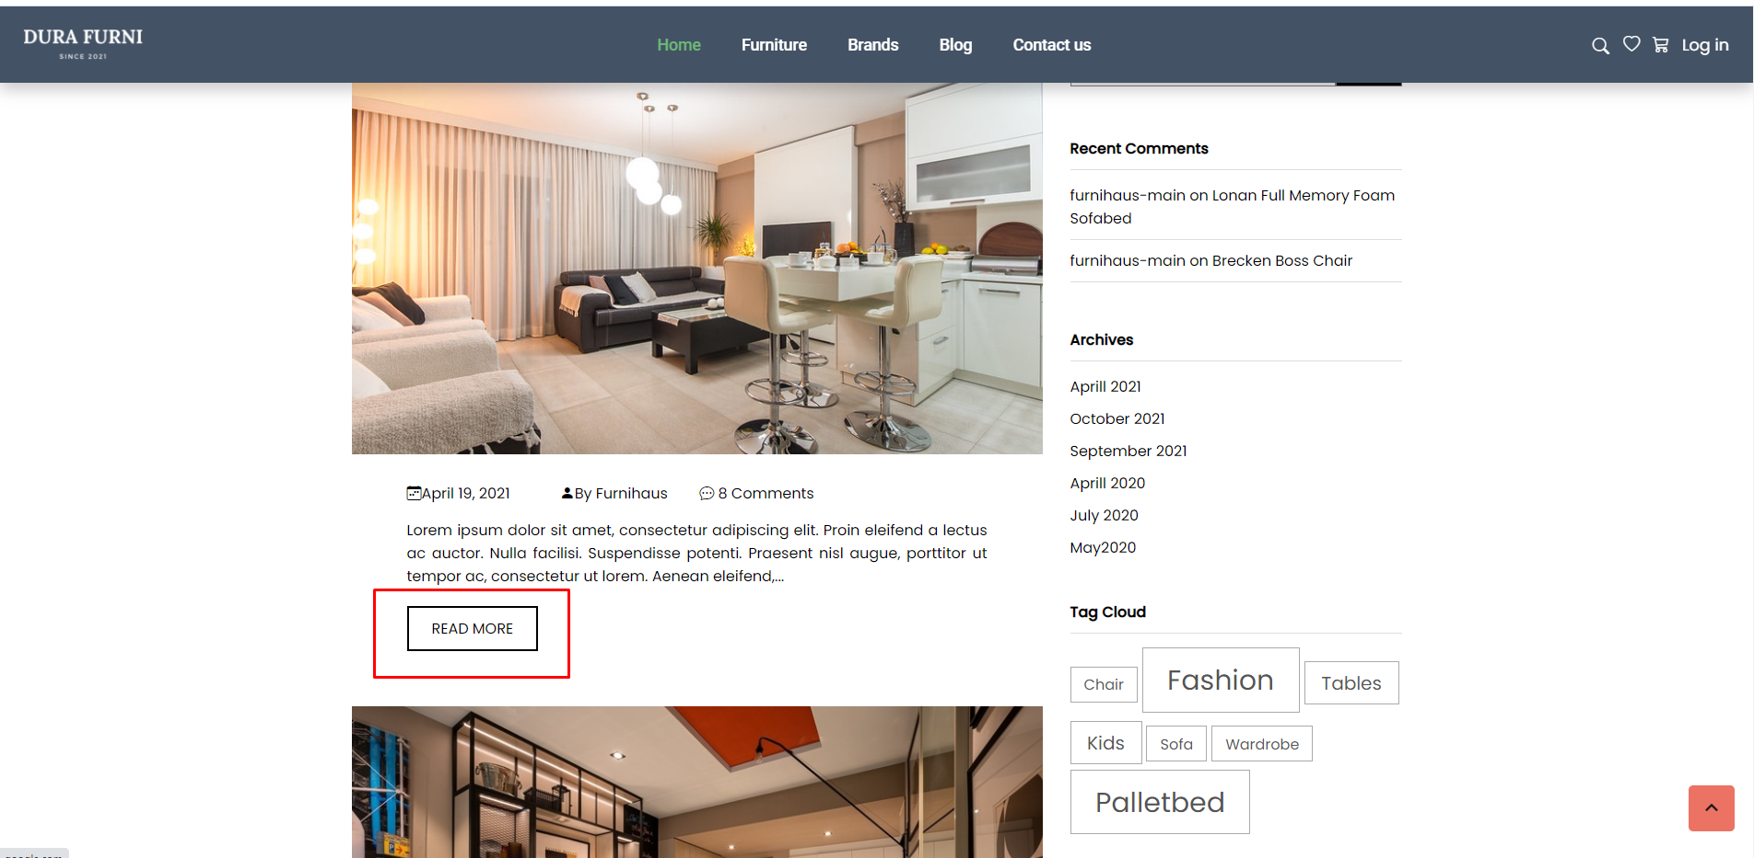

In the Sidebar section there are short information related to the article content such as Tag Cloud and Meta.

**Contact Us: In the navigation bar**

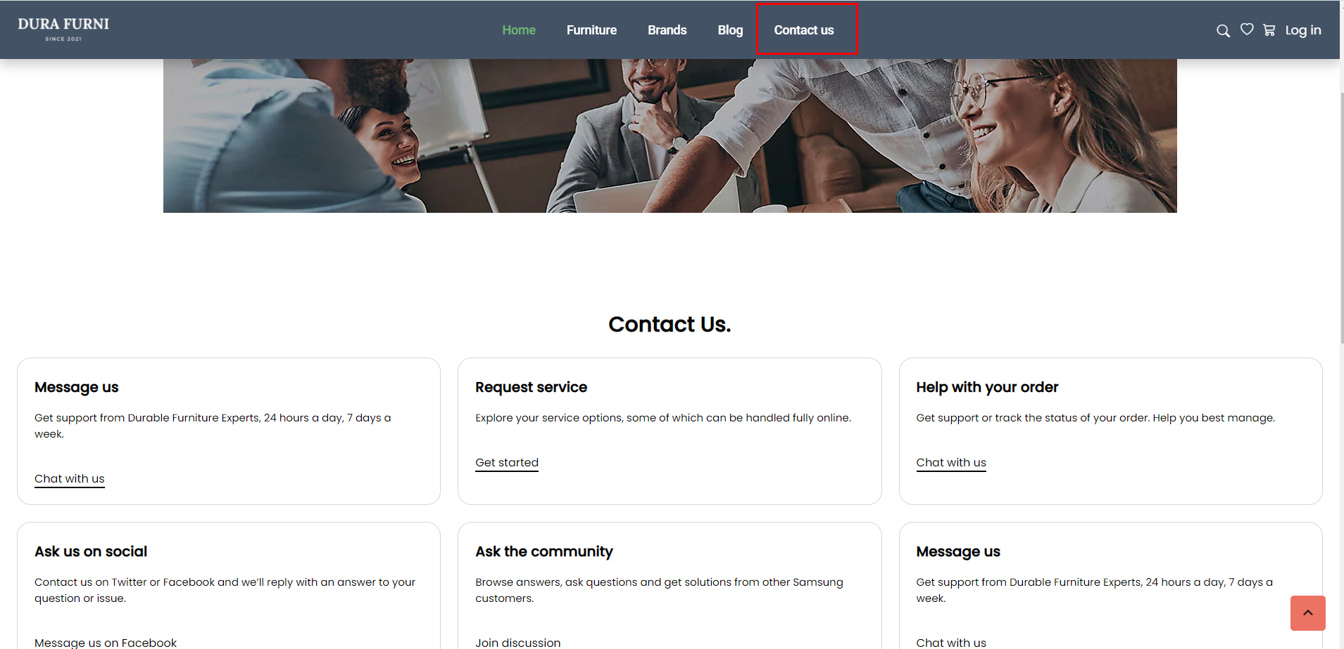

When you click on contact us, the browser window will show the problems you have, you can click on each item and send us an email about your problem.

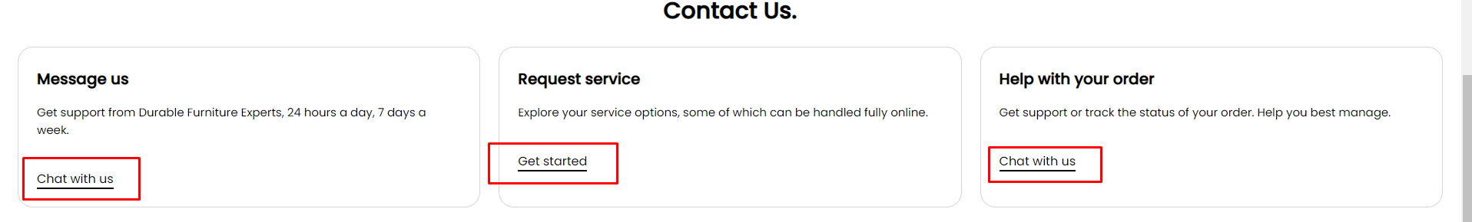

When scrolling down, customers can see the addresses of our showrooms with contact phone numbers.

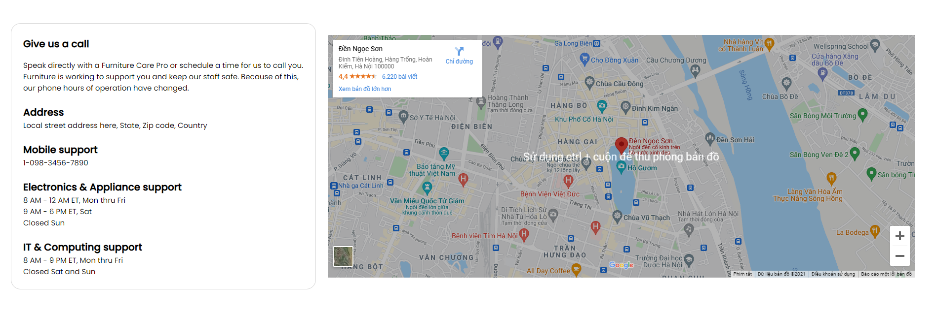

At the right end of the navigation bar there is the section of User’s Connection:

- Search: To find related articles or products that customers need to find on our website

- Wishlist: To help customers save their interest and favorite products, track and purchase products. To help sellers know which products customers are interested in in oder to offer the ways to reach the customers.

- Cart item: To save the products selected by the customer into his shopping cart. When pointing to the cart, it will display the number of products and the price of the product the customer has selected. In addition, the window also displays the following items: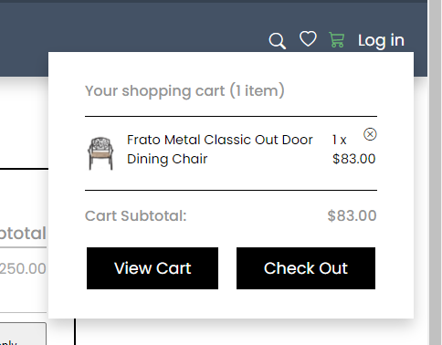

**View Cart: Go to the Cart page in detail**

**Checkout: Go to the Checkout page**

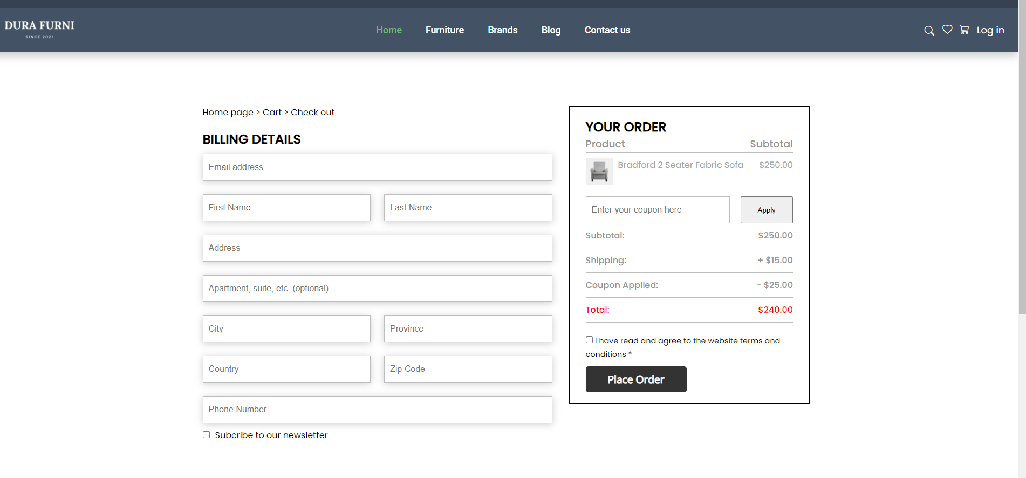

* Login: In this section, customers can register as a regular customer of the website or log in when they are already a loyal customer.

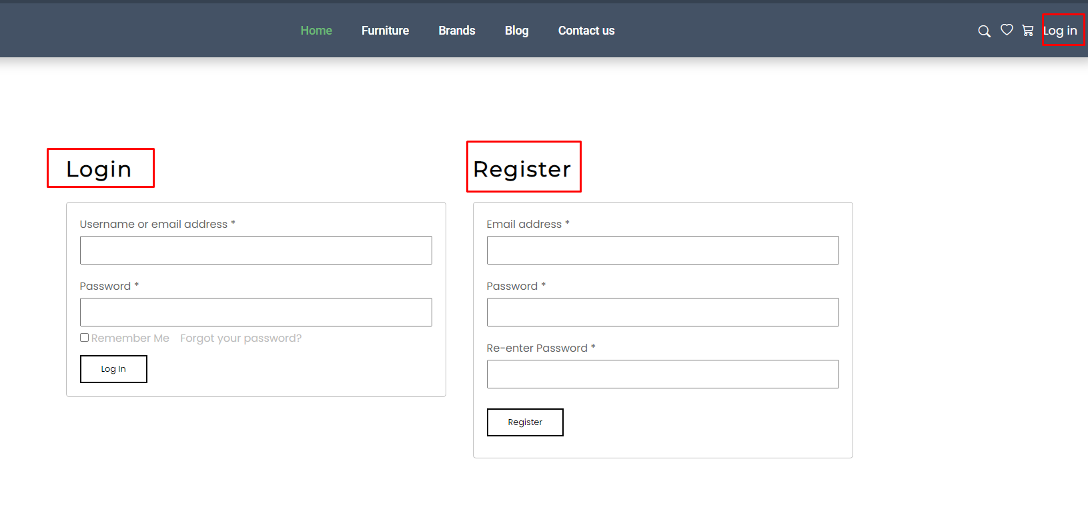

**Footer:** Company information, customer care and purchase terms.

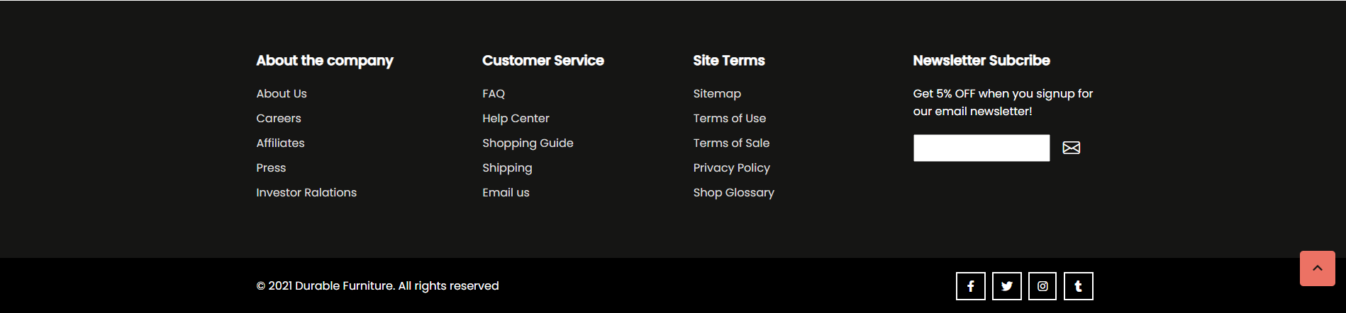

**About us**

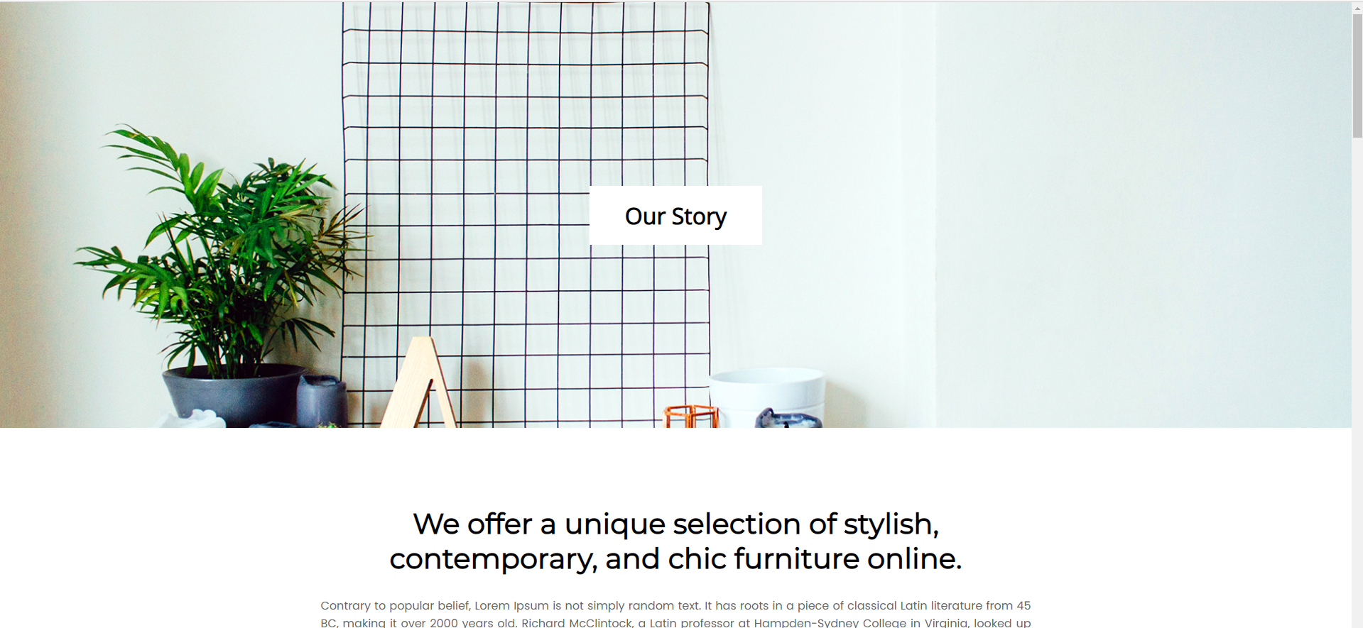

**My Teammates**



**Our Clients**

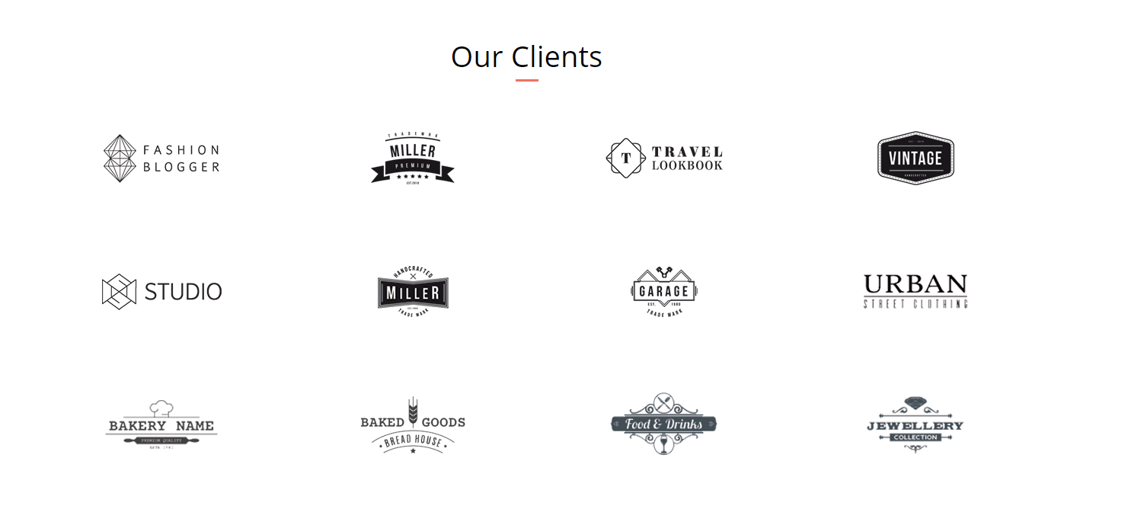

**6. User Guide**

**6.1. Site Map**

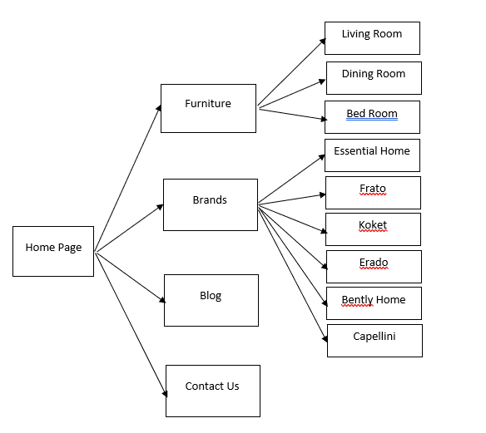

**6.2 User Guide**

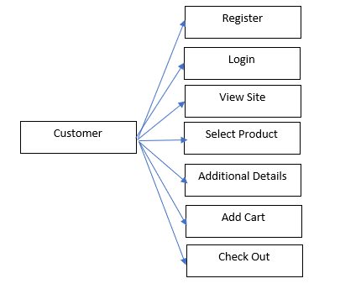

**6.2.1 Register and Login**

In the homepage, you can register as a new member and login:

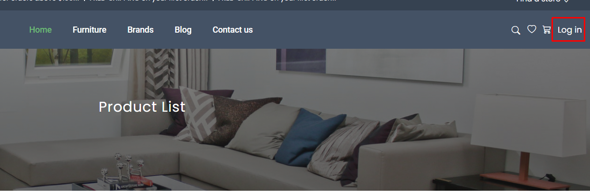

The interface like the figures below:

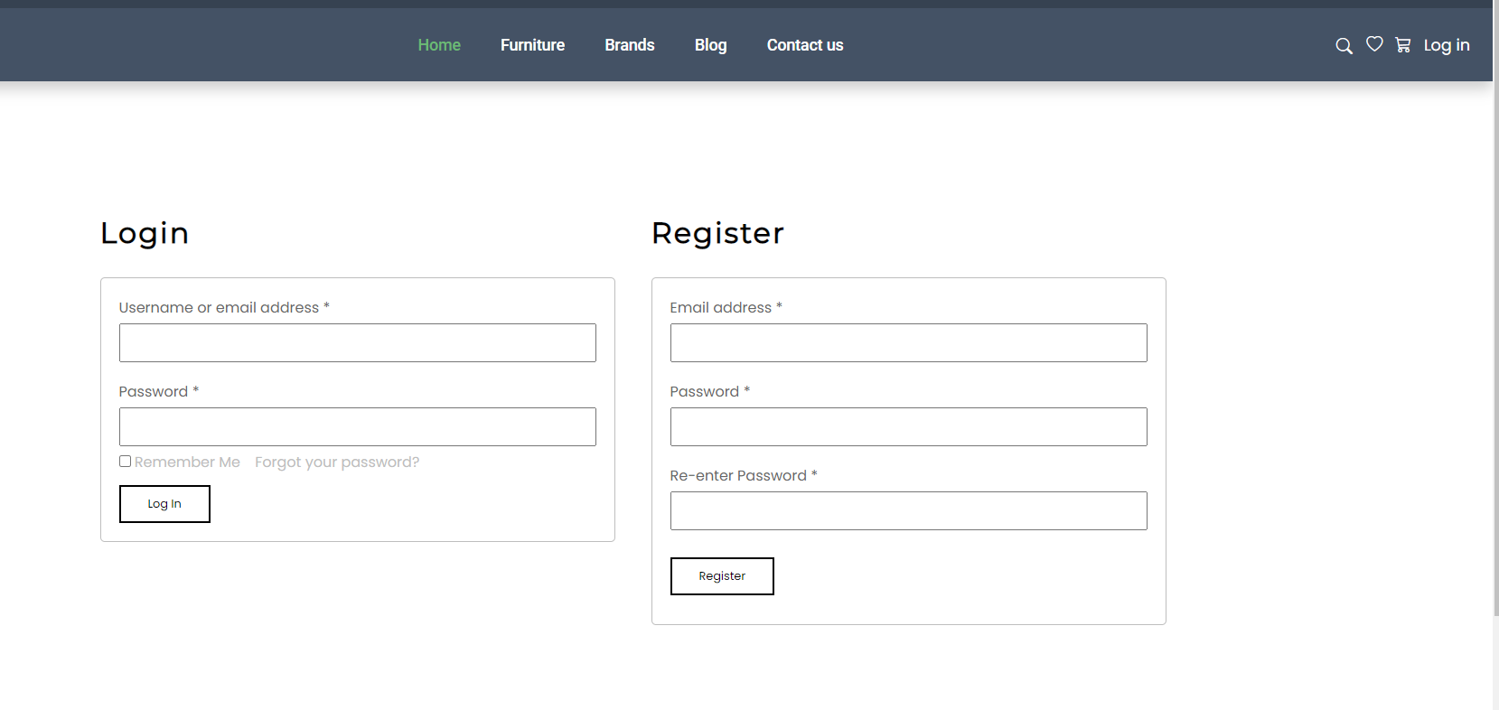

**6.2.2. Website link**

On the homepage we create links to popular products on the website as shown, You can easily access events about popular or discounted products on our website:

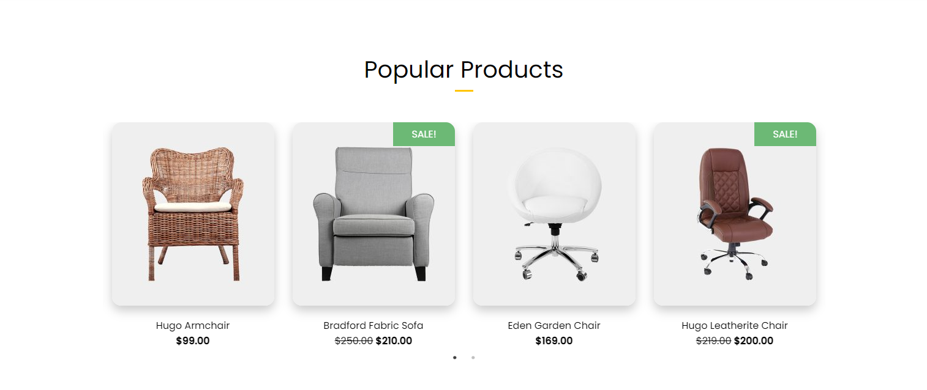

**Or you can go to the “Hot New Arrivals” section to see a recommendation of the products that we have classified by the interior of each room type:**

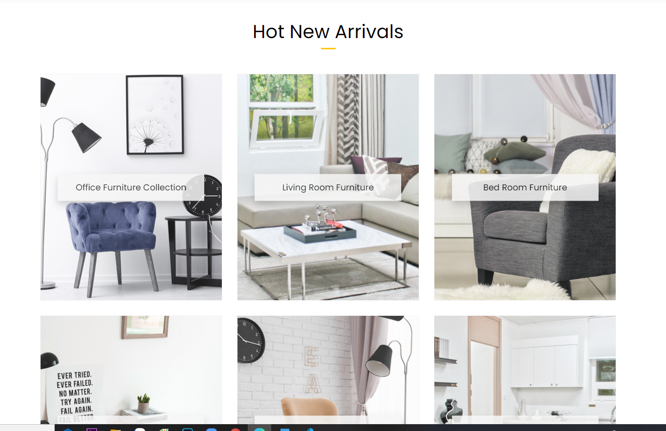

**7. Developer guides:**

We use html5, css3 (with grid and flex to create layout), Javascript and Jquery to build the website. Some simple jquery plugins are used, so if the developer want to maintain the website, please follow these instructions:

**7.1. Download Source code.**

- Go to

- Click on button: “Code”

- Click copy

- On cmd, choose the folder to save project then type command:

git clone

**7.2. How to maintain html code**

- We separate source code into 21 pages, each page namely: [Name of page].html. See the illustration below:

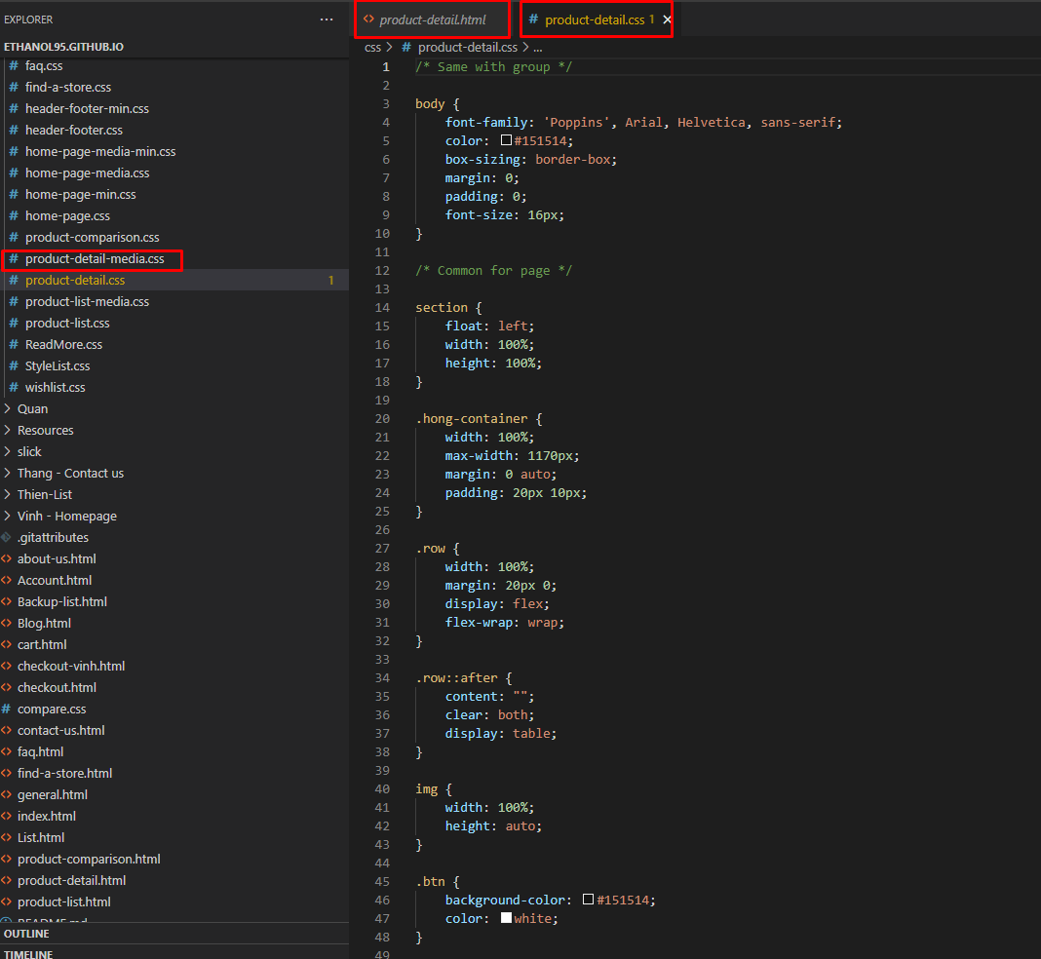

- In every page we comment every section to define each part. Example:

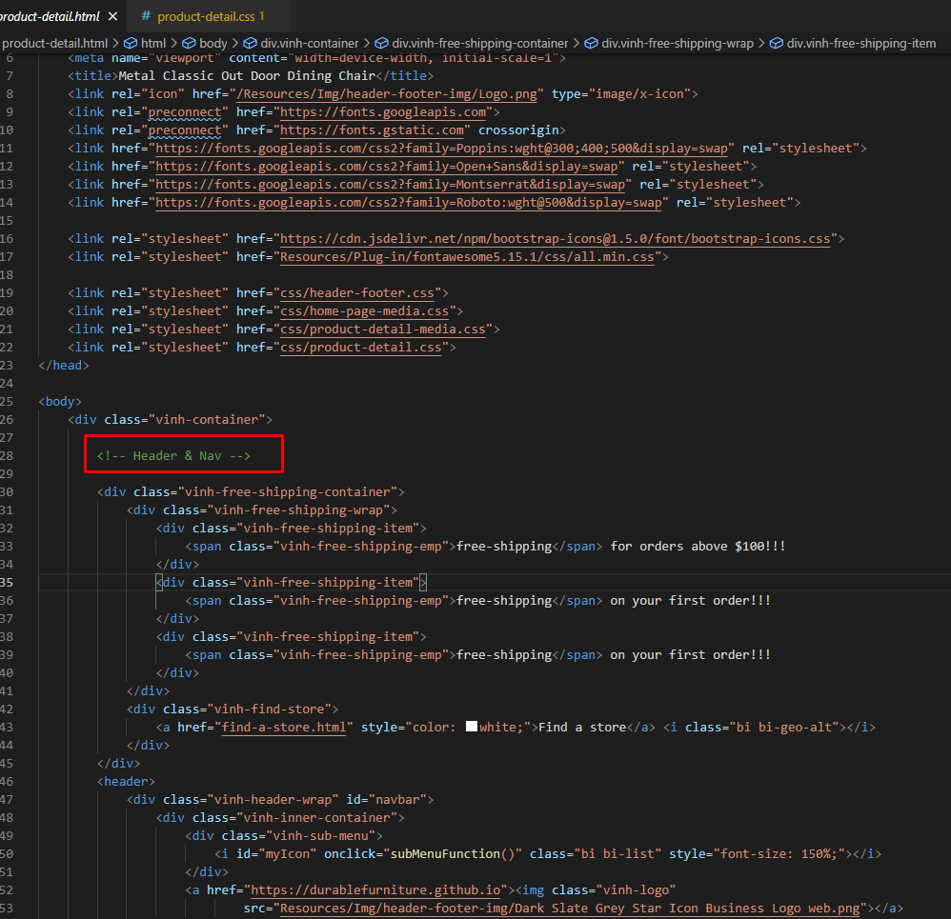

- Find the part name and change source code needed for maintenance.

**7.3. How to maintain Cascading Style Sheets and responsive**

- We namely the part of Cascading Style Sheets source code as: [Name of page_page_css], and each page, we namely each section source code as: [Name of section] See the illustration below:

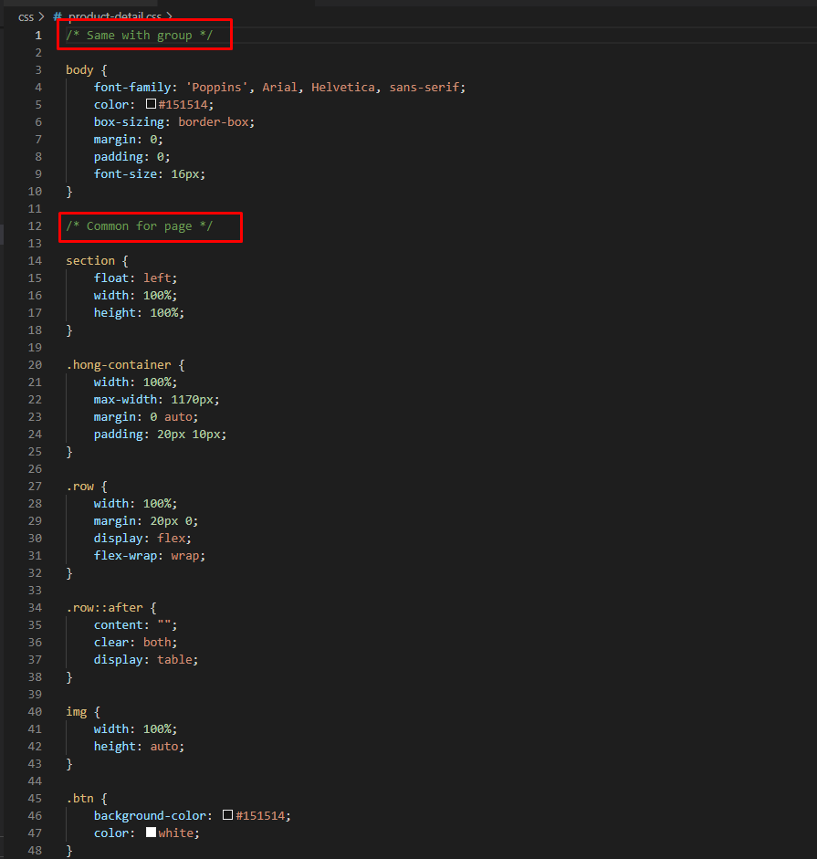

- Find the part name and change source code needed for maintenance.

**7.4. Extension**

- Install “live server” in Visual studio code for run live website (no need to reload website when every time update source code) follow step by step below:

+ Click on Extensions button on Visual Studio Code.

+ Type “live server” on search bar.

+ Click on “Install” and wait to setup complete.

+ Restart Visual Studio code.

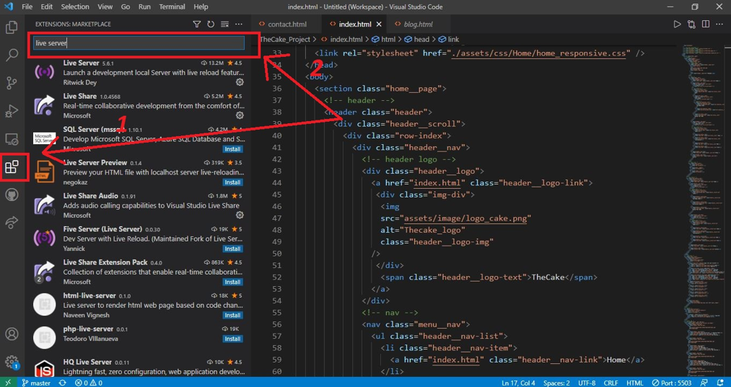

**7.5. Browser support**

- Support chrome browser version 57.0 and above.

- Support firefox browser version 52.0 and above.

- Support IE browser version 11.0 and above.